Jack May, John Wesley Hayhurst, Juan Vallejo

Professor Edward Brash

Physics 341

4 December 2, 2014

AMD and Intel: A Statistical Analysis of Processor Performance and Benchmarking

Computers are an integral piece of the puzzle that is modern life; they are utilized in both professional life and for leisure, they inhabit every room in a modern household, and one can even carry computers with more power than could have been dreamed of.

Inside any of these devices you will find the Central Processing Unit, or CPU, this is the brain of the computer, an overused analogy, but it is overused for a reason. It the part of the computer where most of the actual computing, or thinking to continue the brain metaphor, occurs; nothing happens on a computer without at least running through the CPU. As the most critical portion of what is arguably the most important device one uses on a daily basis, no small amount of attention is dedicated to deciding which brand of processor is most desirable inside a consumer’s computer.

Today the market for CPU’s has been largely been controlled by two rival companies, Advanced Micro Devices, better known by the abbreviation AMD, and Intel, both of which began business in manufacturing and developing CPU’s shortly after their invention in the 1960’s. If there is a debate surrounding processor performance in either desktop or notebook computers, comparing and contrasting the two companies is inevitable, and when attempting to deduce which company produces the highest performing processor from a statistical standpoint, a commonly used tool is benchmarking. Benchmarking refers to a number of different metrics which are used to compare the performance of CPU’s in a numerical fashion, and there exist numerous different techniques of benchmarking to highlight the strengths and weaknesses of any given processor.

Some of the most common criterion for analyzing processor performance are the speed at which the processor operates at, or clock rate, and the number of CPU’s, alternately named cores, that are a part of a processor, and can be physical or virtual. Also an important part of the discussion of differing processors is whether benchmarks themselves are a legitimate way to criticize the power of a processor.

The CPU simply stands for central processing unit. The CPU is a chip in the computer that carries out instructions including, basic arithmetic, logical, control, and IO (input output) for all programs run through the computer. Basically if you do not have a CPU your computer will not work it is the brain, the powerhouse, the central processor for the computer. So with something so essential to the computer picking one that will fit your needs is extremely important. Some background information that will be useful to know for this paper is knowledge in CPU cores, clock speed, and CPI. The clock speed is the speed at which the clock ticks which is measured in gigahertz which is a billion hertz a second. Clock speed is normally abbreviated as GHz. An example is a CPU that runs at 3 GHz runs 3 billion clock ticks a second or 3 billion clock cycles a second. The CPI or clock cycles per instruction is a valuable variable to determine the performance of the processor. The CPI tells how many clock cycles the processor takes to complete one instruction. Finally CPU cores are multiple CPUs put together to form a multi-core processor. These multi-core processors are now just referred to as CPU's because of how frequent they are used; in-fact a single core CPU is almost impossible to find unless you are looking at old and outdated hardware. These multi-core processors have two different types of cores, physical and virtual. A physical core is exactly what it sounds like another physical CPU in the processor. A virtual core is a bit harder to explain but in layman terms it is a simulated CPU that is used in a CPU to split up the process load on that core.

The Companies that we are analyzing are the two biggest names in computer hardware; Intel and AMD. AMD stands for Advanced Micro Devices that was founded in 1969. AMD in the public eye have been known for creating affordable CPU's, having a lot of physical cores, and having high clock speeds. Intel was founded in 1968 and in the public eye have been known for high end CPUs, focusing on less physical cores and more virtual cores, and having lower clock speed than AMD CPU's. While there are other processor companies that exist they are not widely known and will not be used in this study. The reasoning for this is because those companies generally create mobile CPUs for use in phones, tablets, and other electronic devices. This study will focus on desktop computers and laptop CPUs. This study will exclude these mobile CPUs because of the availability of benchmarks for those processors.

Benchmarks are important to consumers looking to buy a CPU. A benchmark is a comparison point at which the consumer can see if they are getting a good value for their money. These benchmarks do various tests to see how well a CPU performs under stress, at a normal workload, and for graphical processors how many frames per second the processor can get. A stress test will test a heavy instruction load generally a heavier load than would be found in a normal computer program run. This information can be useful to see how far you can push your computer with what it can do. A normal workload sounds just like what it sounds like; this workload closely resembles a normal instruction set run by an average program. For a graphical processor the test is on frames per second. Frames per second or FPS is how many frames of animation take place in a single second. This will determine how smooth an application looks. A standard fps for movies is 24 while the standard for computer applications is 60. Benchmarks are useful but determining how useful they can be is up for debate but as of now they are the best tool a consumer has for picking out a CPU.

Why are there performance differences when comparing AMD and Intel processors that are clocked at the same speed? Comparison results between AMD and Intel chips show significant performance differences between the two kinds of chips, even when both chips tested have the same clock speed.

The heart of this issue is more easily examined by breaking down each chip into its basic structure and architecture.

A CPU is formed by logic units, caches, registers, and pathways that come together with many other components using differing internal designs. An instruction may be able to be carried out by two processors using different internal designs, but the way in which such instruction is carried out will differ either slightly or greatly in both processors.

When a CPU carries out an instruction, it breaks that instruction down into simpler parts, and those simpler parts into even smaller parts. Depending on the internal structure of the chip we are using, the order in which these smaller parts of the instruction are processed will vary greatly. Some of these smaller parts depend on the result other simple parts will yield within the same instruction. This causes the order at which the broken down parts of this specific instruction are processed to vary.

This is a main factor for differences in performance between an AMD chip and an Intel chip clocked at the same speed. The number of smaller steps that are done out of order, how much an instruction is broken down into simpler steps before being processed piece by piece, and the speed at which each individual part of the instruction is processed all influence the overall performance of each chip.

Processor performance does vary, as previously discussed, even when the processors being compared clock at the same speed. The number of cores on a processor does in part influence this.

A processor having multiple cores is a topic in conversations about high performance. But, while a high number of cores sounds beneficial towards achieving a higher performance, how efficiently it runs is heavily influenced by how well applications are optimized to make use of the extra cores on the processor.

From an average sample size of 331, an Intel Core i3-4350 @ 3.60GHz is compared against an AMD FX-9590 Eight-Core in terms of performance and value. Both chips contain 4 cores, with the Intel chip containing 2 physical and 2 virtual cores, and the AMD chip containing 4 physical cores. Both chips are priced closely. In terms of performance, the AMD chip with 4 physical cores receives a performance score that is twice of the Intel chip containing 2 physical cores and 2 virtual cores.

Performance for these chips is measured in terms of efficiency performing mathematical operations, compression, encryption, and SSE.

Intel  Alt text

 AMD Alt text

To further expand, from an average sample size of 5, an Intel Xeon X3460 @ 2.80GHz is compared with an Intel Core i3-4350 @ 3.60GHz. A close to similar performance benchmark is shown for both chips despite their differing amount of cores reinstating a conclusion that the number of cores does not always determine whether a processor will outperform another one.

Intel Core i3 Alt text  
Intel Xeon     Alt text

**Benchmark Comparison**

**Intel**

| **Release Date** | **Chip Name** | **Sample Size** | **Performance Score** | **Clock Speed** | **Cores** | **Price** |
| --- | --- | --- | --- | --- | --- | --- |
| July 2010 | Intel Core i7-970 | 140 | 8550 | 3.20GHz | 6 | $885 |
| Nov 2008 | Intel Core i7-960 | 518 | 5940 | 3.20GHz | 4 | $562 |
| July 2010 | Intel Core i5-3330 | 772 | 5894 | 3.00GHz | 4 | $182 |
| January 2013 | Intel Core i3-3210 | 82 | 3906 | 3.20GHz | 2 | $117 |

**AMD**

| **Release Date** | **Chip Name** | **Sample Size** | **Performance Score** | **Clock Speed** | **Cores** | **Price** |
| --- | --- | --- | --- | --- | --- | --- |
| 2013 | AMD FX-937 | 275 | 9590 | 4.40GHz | 8 | $204 |
| 2011 | AMD FX-8150 | 1121 | 7696 | 3.60GHz | 8 | $183 |
| 2011 | AMD FX-8350 | 4921 | 9014 | 4.00GHz | 8 | $173 |
| 2012 | AMD FX-4100 | 1077 | 4041 | 3.60GHz | 4 | $101 |

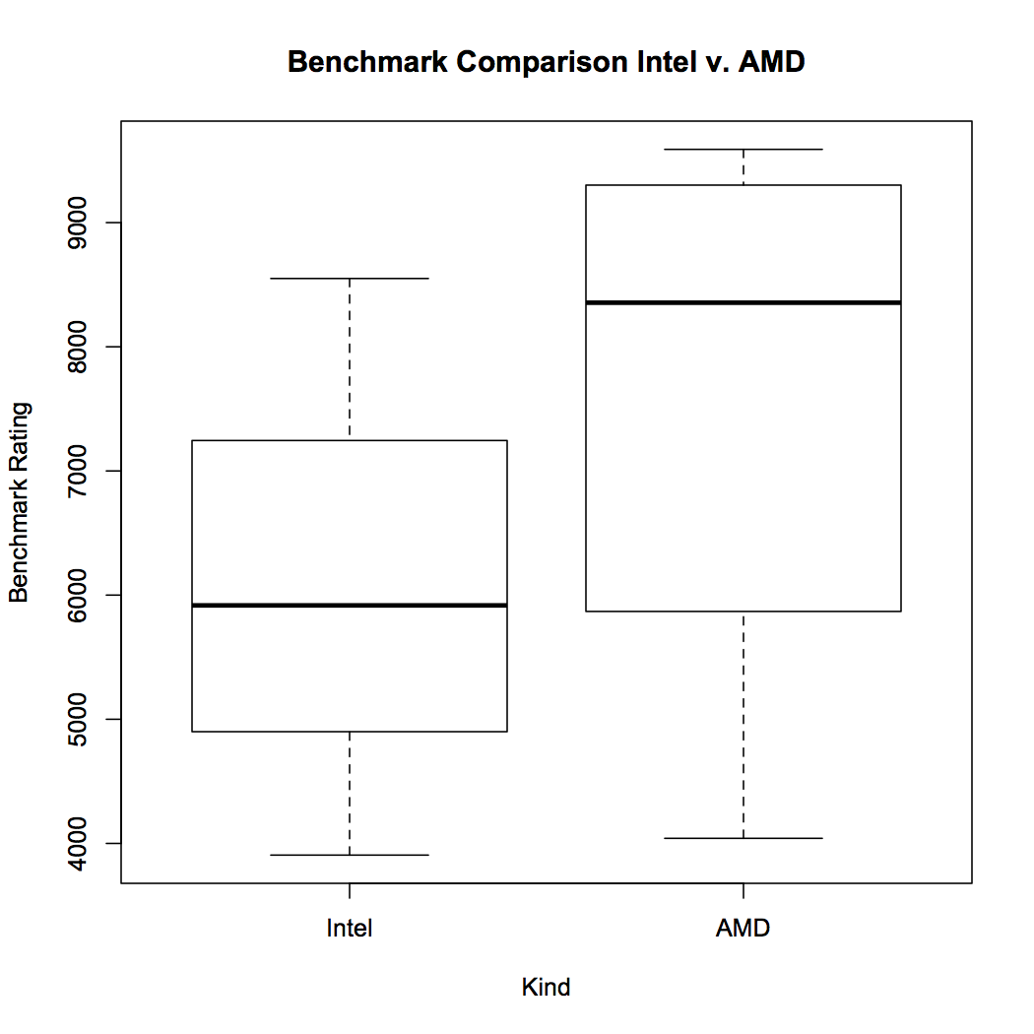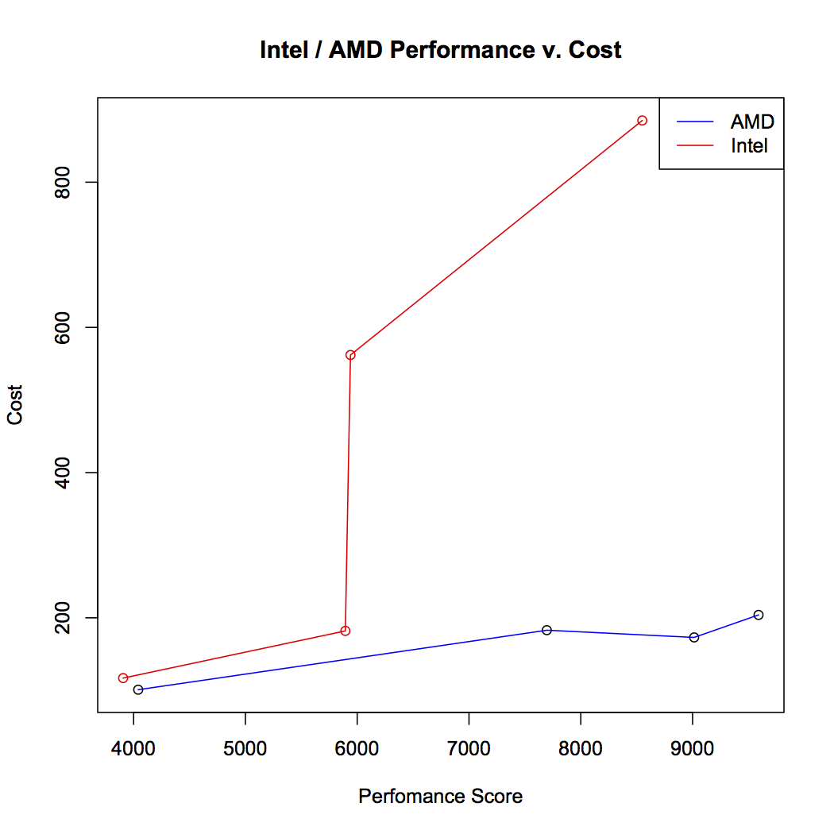

The box plot above is a graphical comparison of performance scores in the Intel and AMD chips showcased in the data tables provided.

**Further comparison of Processor Speed to Value**

**Ratio of Clock Speed to Price (Intel)**

| **Release Date** | **Chip Name** | **(Clock Speed / Price) Ratio** |
| --- | --- | --- |
| July 2010 | Intel Core i7-970 | 0.00362 |
| Nov 2008 | Intel Core i7-960 | 0.00569 |
| July 2010 | Intel Core i5-3330 | 0.01648 |
| January 2013 | Intel Core i3-3210 | 0.02735 |

**Ratio of Clock Speed to Price (AMD)**

| **Release Date** | **Chip Name** | **(Clock Speed / Price) Ratio** |
| --- | --- | --- |
| 2013 | AMD FX-937 | 0.02157 |
| 2011 | AMD FX-8150 | 0.01967 |
| 2011 | AMD FX-8350 | 0.02312 |
| 2012 | AMD FX-4100 | 0.03564 |

While the development of CPU’s containing multiple cores has undeniably been a marked improvement to how computers are developed, and what the capabilities of such machines may be; it still bears investigation of the impact of additional cores on modern CPU’s. The difference between Intel’s practice of using processors that tend to have fewer physical cores, but an equal amount of virtual cores, whereas AMD has an inclination towards producing CPU’s with a higher number of physical core as compared to what Intel produces, however they do not generally have any virtual cores. The main benefit afforded by producing a multi-core machine does not lie in a direct boost to the clock speed of a given processor, which is to say that a machine with four cores and a clock speed of one gigahertz is not equal in performance of a single core machine that clocks at four gigahertz; however it greatly boosts a computer’s capacity in terms of parallel processing, therefore if a single core processor has a speed of one gigahertz, it will under perform when compared to a multi-core processor that has the same clock speed.

With data on the top thirty ranked processors from Primate Labs Geekbench benchmarking software the number of cores varies from 80 to 28 cores, with an average of 41 and a standard deviation of 15, there is a large amount of variance between the number of cores the highest performing CPUs, whereas most of those same processors have little variance relatively in clock speed, they all hover between 2.8 gigahertz and around 3.6 gigahertz. The issue with comparing the effect of cores to the effect of a higher clock rate is difficult due to issues within software rather than ones related to the hardware. To fully access the potential of a multi-core processor requires software to be specifically tailored to that processor with its own particular number of cores, whereas different processor speed are easier to compare to one another. While having multiple cores may be as useful as having a higher speed processor it is much less likely that any given piece of software will be optimized with a given architecture in mind, therefore from a consumer’s standpoint processor speed is a more important metric for a better processor than the number of cores, however the number of cores is a significant secondary factor in searching for a powerful processor.

Why are benchmarks used? Benchmarks are used for good reasons and a multiple bad reasons. Benchmarks are used simply to measure the performance of multiple processors. Benchmarks are a go to for performance for a multitude of reasons. First the available information on a CPU is extremely limited on a store listing or even on the box itself. Second the way the benchmarking program is a great way to see how well a processor performs in real life not just a lab. Finally benchmarks are a good way of seeing how much value you are getting for the price you pay. Benchmarks generally include the name of the processor, the score the processor receives, and the cost of the processor. Unfortunately even with all of these good things benchmarks are able to provide, benchmarks suffer from some of the worst pitfalls imaginable.

The first and major problem of benchmarks is that for processors the code they run to test is not always optimized for those specific types or architecture. While that argument might sound silly it doesn’t effectively test the hardware. Imagine that a benchmarking program that isn’t optimized for any specific hardware, that benchmarking software isn’t making use of the hardware’s potential ability. Rather it is testing how well code can be pushed through the hardware. This is not an accurate measure of the processor because one benchmark might say that an AMD processor is better than an Intel processor but with optimization the Intel processor can out preform the AMD processor when both have proper optimization.

The next problem with benchmarks, more so for CPU benchmarks, is the use of multiple cores. This is important for AMD processors as generally they have up to 8 physical cores to process information. This will help the computer to multitask by dividing up the instruction sets to the different cores of the CPU. The biggest problem is that most benchmarks do not test multitasking capabilities. Most benchmarking software really can only test 2 cores effectively in order to be fair to a majority of CPUs. This has started to shift in a more positive direction with some programs being able to test up to 4 cores effectively. With the newest Intel chip actually having 8 physical cores along with AMD already having a long line of 8 cores already; it can be assumed that the benchmarking software will then shift to being able to test more than 2 to 4 cores.

Another problem that benchmarks do not test is the disparity between operating systems. While the benchmarking programs have to worry about optimization for hardware they also have to worry about optimization for the operating system. The way a program sends instructions to the CPU also depends on the operating system. This can make a certain program run slower of faster depending on how well optimized it is for that specific operating system. An example of this is how well ITunes runs on windows vs. an apple computer. ITunes is developed by apple and thus will be optimized for an apple computer. Windows can run ITunes but it does not run it well. This is not because the hardware on a mac is better rather that the program itself is optimized to run better on an apple computer than a computer that runs windows.

The most problematic thing about benchmarks is that rather than telling you what the processor is mostly used for, the price of that processor and the power consumption of that processor; they put out an arbitrary number that is a comparison point for the different processors. This is, however, better on graphics cards because the comparison is generally on frames per second but still some benchmarks use an arbitrary score. While the benchmarks will show the difference between the two processors in terms of processing power, minus the problems listed beforehand, does not give a measurable difference in numbers. What is the difference between a processor with a result of 9,000 and another one with 11,000? The simple answer is 2,000 but what does that mean in terms of processing power, power consumption, and multitasking? Even more so what is the difference between one that scores 7,000 and one that scores 6,996? Does the difference of 4 even matter with such high numbers?

Unfortunately even with all the problems of benchmarks most people still use them as an entry point of determining what processor to buy. The reason why even people who know of the pitfalls still use benchmarks is because of the lack of information available about a processor when buying one. Looking at a Newegg store page for an AMD processor, the information available are: the number of cores, the operating frequency, the L2 cache, L3 cache, and the power consumption. Nowhere in the information provided is the CPI listed. How you determine the performance of a processor is the execution time where the instruction set is the same between the two processors being compared. The execution time of a given processor is determined by the number of instructions multiplied by the CPI; then that number is divided by the clock rate of the processor. This is why the clock rate is not the only determining factor when comparing processors. So without companies able to release a CPI number and the corresponding instruction set, benchmarks is a way to get a gauge of the performance of a given processor.

The best way to fix the problems with benchmarks is to show the execution time rather than the arbitrary number that is produced. Show the CPI of the processor along with the instruction set as well. How to fix the multi-core benchmarking problem honestly cannot be solved simply. Sure you can find the CPI and then find the execution time but that will not account for how well the processor will do running multiple programs. The fix to this is simply a choice between what type of processor you are looking for and what kinds or programs you are going to be running. Intel has a reputation for being the go to processor for gaming and that holds true for the most part. Games make use of up to 2 cores on a given processor, meaning if your processor only has 2 physical core and 2 virtual cores then yes games will run better on that machine. In contrast if you are trying to render videos, compile code, or any task that will run multiple programs at once then an AMD processor which in general has 4 physical cores then you should look to getting a AMD processor. Laptops have a limited power supply meaning that if you are trying to expand the up time of it then you should lower the power consumption. This means the power consumption of your CPU will make a huge impact on the lifespan of your battery. In this case numbers are easy to look at and see that Intel has a lower power consumption rate than an AMD processor. If money is an issue then you want the best price per performance. AMD typically is cheaper than Intel while still competing in the performance department. All of these factors matter when shopping and choosing the right processor for you.

While it may be accurate to say that usefulness of benchmarks may be dubious, especially from a consumer’s standpoint, it is clear that the issues lie within how the benchmarks are used. It may be due to improperly optimized instruction sets for a given architecture or failing to account for differing operating systems. Additional problems arise with benchmarks when failing to account for the number of cores contained within a given CPU, not to mention that often benchmarks give seemingly arbitrary numbers to associate with performance while giving no concrete feedback to the user to indicate what a given number signifies, or what the difference of two numbers indicates. Analyzing results of benchmarks seems to indicate that rather than relying on the word of a benchmark, which may or may not be produced by individuals who have an agenda to show that a specific brand of microprocessor outperforms its’ competitor, it is better to look more at specific details about the processor, the stronger metrics being the rate at which the processor clocks at, and how many cores form the processor has.

When studying clock rates of processors as a benchmark, it is important to keep in mind that two different processors which clock at the same exact speed do not always benchmark at the same value, however clock speed is a crucial metric when analyzing the quality of a CPU, while the exact clock rate may not make a difference between two processors that clock at three gigahertz a three gigahertz processor will always almost always outperform a CPU with a clock rate of two gigahertz. Frequently the reason for two separate microprocessors with the same clock rate performing differently is a result of the number of cores the processor has, while it may not be as strong of an indicator of power as clock rate, processors with more core will perform better than ones with less cores, and a greater number of physical core impacts performance more positively than the impact of virtual cores. Ultimately the difference between AMD and Intel comes down to a matter of personal preference, both brands make similar products for similar prices; either company provides a quality product that has the ability to satisfy the needs of almost any consumer, but that will never stop anyone from debating which brand that deserves to be on top.

Sources

http://www.howtogeek.com/177790/why-you-cant-use-cpu-clock-speed-to-compare-computer-performance/

http://www.integratedsolutions.org/benchmarks.htm

https://kb.wisc.edu/page.php?id=4927

http://www.tldp.org/HOWTO/Benchmarking-HOWTO-1.html

http://www.jstor.org/stable/i27594128

http://goo.gl/FP5MmZ

https://www.cpubenchmark.net/

http://www.primatelabs.com/geekbench/

http://www.tomshardware.com/forum/278509-28-intel-chips-lower-clock-speeds

http://techchannel.radioshack.com/comparison-speed-amd-intel-2626.html

http://www.geek.com/chips/why-amd-mhz-dont-equal-intel-mhz-557914/